**In this video we will discuss about**  
How to determine what version of asp.net mvc is being used by an existing mvc application

**There are 2 ways to do this**  
**1.** **At design time** - In the solution explorer, expand "References" folder. Right click on System.Web.Mvc assembly and select "Properties" and you can find the version that's used as shown below.  
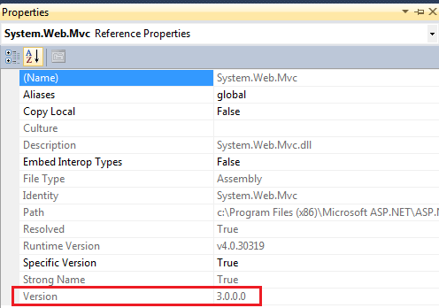   
  
**2.** **At runtime using code** - typeof(Controller).Assembly.GetName().Version.ToString()